Chris Kioschos

Professor Finnoff

Comp. Econ.

06 October 2023

A Tax on Energy & Greater Income

Introduction:

For my policy I chose a tax on energy. I decided to tax energy as it is relatively simple to implement, while still containing far reaching consequences for consumers. Energy usage constitutes a major component of Wyoming's exports, as well as constituting a large portion of what its citizens also consume. It becomes interesting then how a tax on such a product would affect consumer welfare, as their compensating variation increases to offset the loss in utility. Ultimately, a tax on energy is interesting in that it affects both industries and consumers, and reveals the benefits and costs to Wyoming if they were to implement a policy. Put another way, their loss in industry and consumer welfare may offset the gains they have from the tax. Additionally, in my analysis I thought it would be interesting to see how Wyoming could combat this decreased welfare. A simple idea to implement would be a cash injection into the local population, which may offset the taxes on Wyoming consumers. Similar to the COVID relief fund, I was interested in how an increased base income level would affect my findings and results. Additionally, I thought my analysis could (potentially) also be used to show how those with a higher income may be less affected by a tax on energy. By raising the income across the board, you could also view this as the difference between taxing those with average income, and those with greater than average income.

The Model:

I created my model by editing, the class provided, big model that was for a tax. I began by changing the tax from agriculture to energy. To keep things simple I decided to use a similar tax level, as well as use the exact same range of tax levels (tt = (0*9)). After including my tax, there seemed little to change as the model already accounted for changing tax levels. By adding in my tax variable, this value is then substituted for all the equational (i)’s, which shows the effect a tax has on our displayed results. From here, I was then interested in how an increased income affects CV but also how it affected their income percentage, or by what percentage their incomes changed with a tax. To keep things simple I decided to multiply consumers base income by two, to represent a cash injection that doubled the wealth of Wyoming consumers. To implement this, I initially considered doubling just the starting values to represent the higher starting income. However, I instead decided to keep the starting value consistent while doubling every equational usage of base income. This resulted in multiplying the INC_b by two, at least for the equations provided. Additionally, I changed the policy version of income to be equal to double the basic income, to account for this higher income for the policy side of the code.

Analysis:

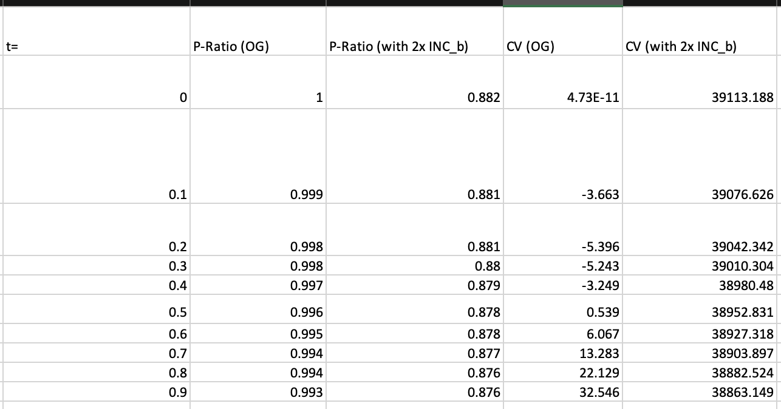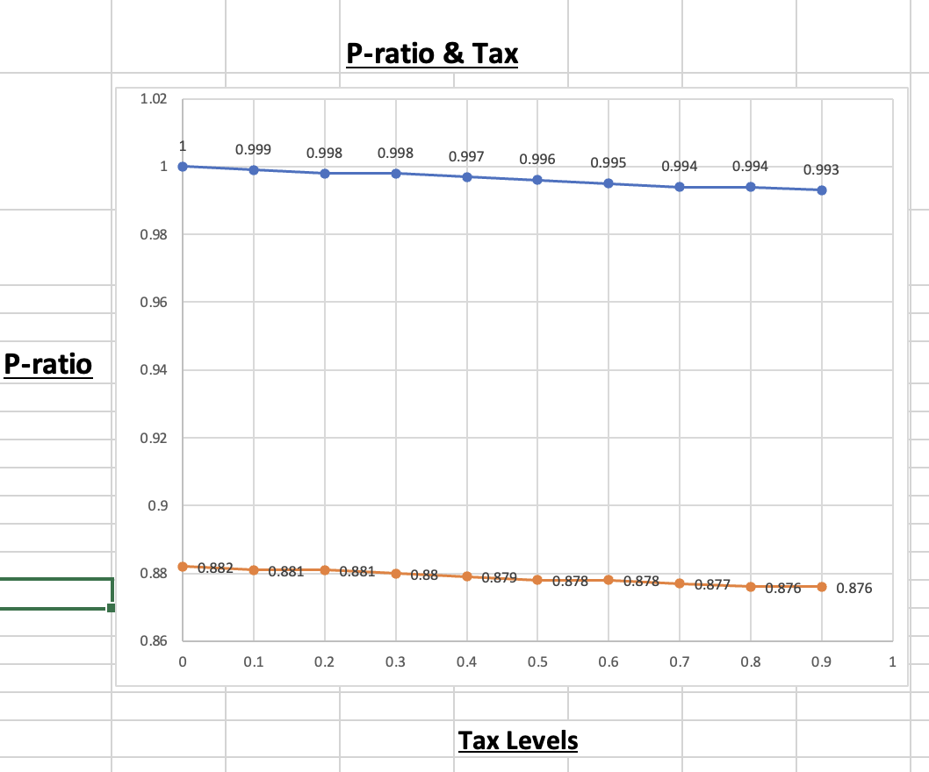

This brings me to my results, which are separated into the two different models I created. The first model (OG) constitutes the different tax levels on energy, and their effect on the price-ratio and compensating variation. These results were to be expected, as the price ratio marginally declines in response to increased taxes. This declining ratio makes sense, as the price ratio declines as the policy price increases while the base price stays constant. This then results in the base price as a smaller ratio, by comparison, to the increasing policy price (which includes taxes). Additionally, it makes sense that compensating variation is growing larger, as with more taxes consumers require more compensation to get back to a similar income level. In other words, it makes sense that it requires more compensation for consumers to hit the same utility before the tax was implemented.

Similarly, the price ratio for those with a higher income also declines. This pattern can be seen when income is doubled, although the starting values are different from the original model. This makes sense as an increased base income may affect starting prices, but would not strongly change the ratio between prices. Lastly, for compensating variation I found that it declined as taxes increased, at least when incomes are doubled. This could show how those with a higher income are affected differently by higher taxes, which may require a different equation. Additionally, it may show that doubling the income means there is less of an effect of taxes on utility, meaning there is less of a relationship rather than a negative one.

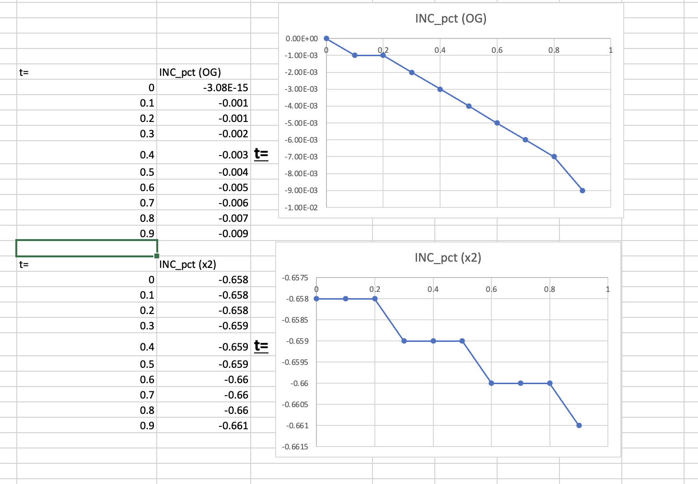

Lastly, I thought it interesting to see how income changed. First as a tax was added, and second as income was doubled. Looking at income percentage changes, or the ratio of the income with the policy compared to the baseline income, I found that it declined in both scenarios. With just a tax, income marginally declined by (-.001) per (.1) increase in the tax. This makes sense as consumers' income (with the policy) declines, while the base income stays constant. By comparison, when income is doubled there is a similar decline but a difference in starting values. Similar to above, the decline is still there but seems to marginally slow, as the decline takes longer than the previous example. This may encourage the notion that the effects are the same in both, but for those with higher income there is less of a noticeable change in income ratio. Put another way, if their income is already higher they will be less affected by a decline in income due to taxes. Additionally, the larger starting values (in absolute terms) may be due to an overall larger ratio as their base incomes have been doubled.

Conclusion:

All in all, I think my model shows the effect of a tax on energy on Wyoming consumers, in addition to showing how a higher base income may affect their response to said tax. I found that a tax on energy would require increasing compensating variation to reach a similar utility. Additionally, I found that those with a higher base income are affected differently, with their compensating variation being less affected by the tax. This may be due to their increased income and utility values, meaning a tax does not seriously affect their utility. Finally, I found that the price ratios decline in both, with an increased income predominantly affecting their starting values. A similar result was seen in the income ratio, with income as a percentage declining similarly despite their distinct starting values. Ultimately, my analysis shows the cost of a tax in addition to the idea that those with a higher income may be less affected.